Current tunnel entrance:

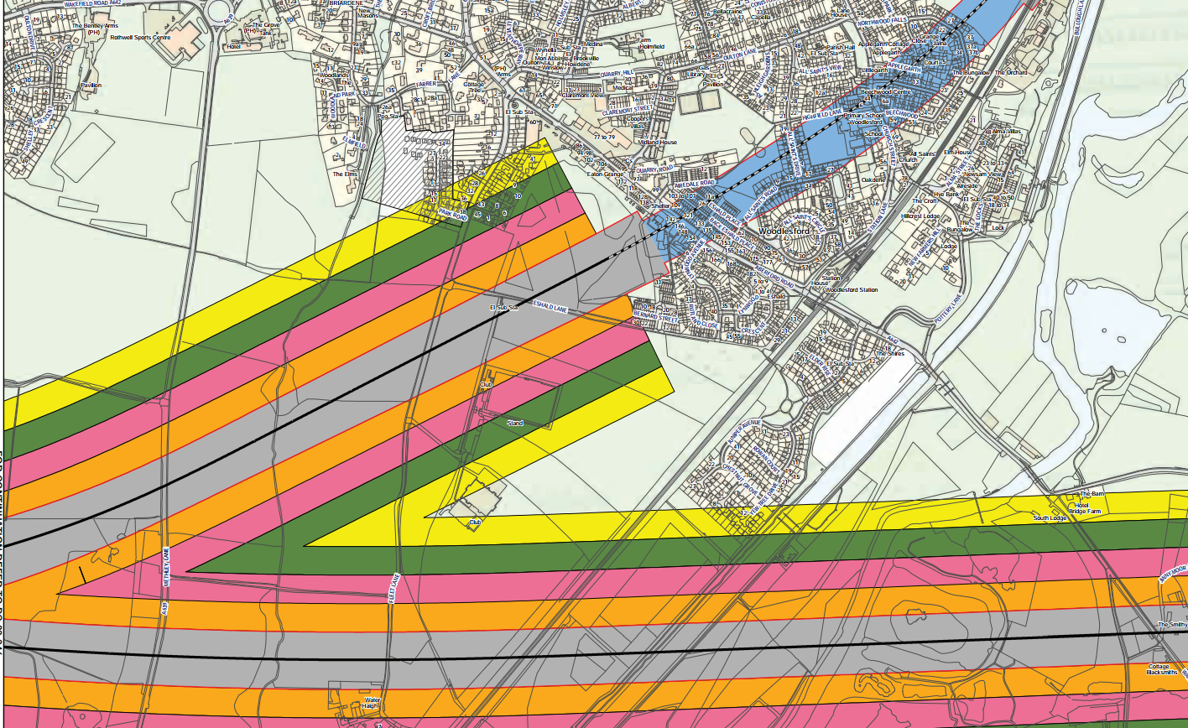

Proposed moving of tunnel entrance:

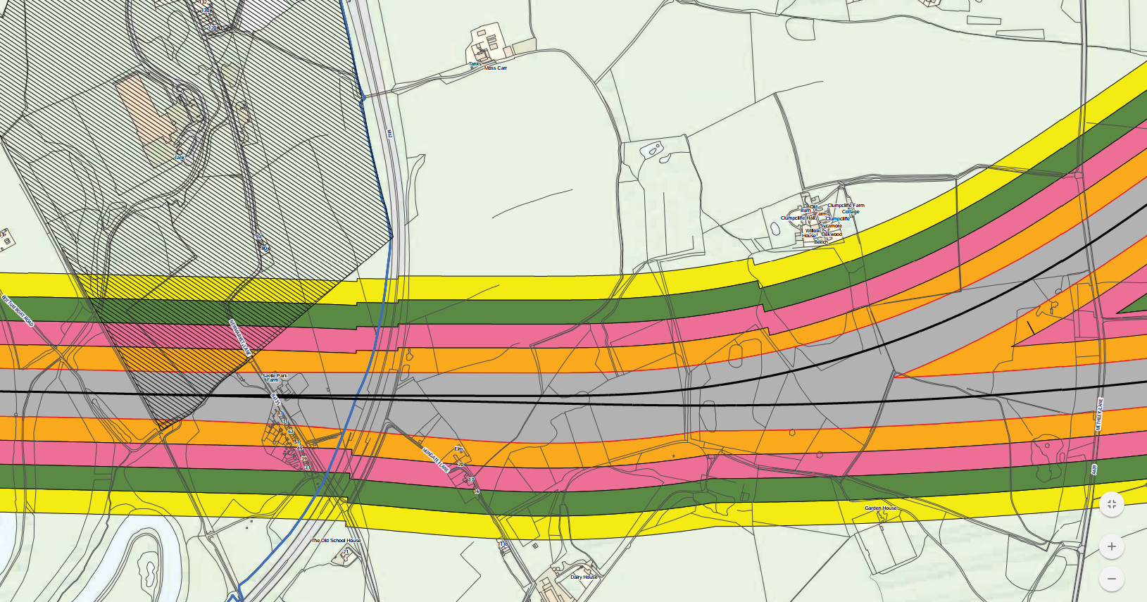

M62

Clumpcliff Farm

The tunnel entrance should be moved back from where it currently is Fleet lane / Eshald lane, to prior to it crossing the M62 (see example red line below). This would vastly reduce blight on the local communities compared to the current proposal